MHS Brick Time
Leave a Lasting Legacy at McIntosh High School
TIME TO ORDER YOUR BRICK! Make sure you leave a lasting memory on the McIntosh Campus. These special bricks will be in- stalled in the courtyard and can be purchased to commemorate graduation, that special victory, remember a special teacher or coach, share words of wisdom, and much more. These timeless treasures make a GREAT gift!! To date we have completed the “M” & “H” and will be starting on the “S.” All orders are tax deductible. If you have any questions, please contact Jenny Taliercio at jenny@cjjs.com or 561-628-2540.
******************************************************************
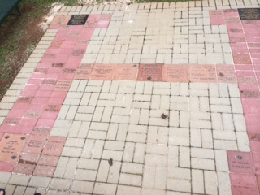
BRICK ORDER FORM
Please complete information below & return with payment.
Cash or check (made out to MHS PTSO).
Check your order carefully before submission. Note: We are not responsible for errors.

PARENT NAME: ______________________________________ STUDENT NAME:______________________
EMAIL: __ __ __ __ __ __ __ __ __ __ __ __ __ __ __ __ __ __ __ __ __ __ __ __ PHONE:________________
TOTAL AMOUNT $_________________ (Check payable to MHS PTSO) #__________ DATE:_____________

******************************************************************

SIZES AVAILABLE TO ORDER: | 04 x 08 | 08 x 08 | 12 x 12

 |  |  | $50 | 4 x 8 brick | Limit of (4) lines of 16 characters per line (including spaces)
 |  |  | $70 | 8 x 8 brick | Limit of (6) lines of 16 characters per line (including spaces)-  See back page  ^{See back page}
 |  |  | $90 | 12 x 12 brick | Limit of (10) lines of 23 characters per line (including spaces)-  See back page  See back page
 |  |  | $12 | Symbols | Each symbol takes two characters of space per line. -  See back page for symbols
4 X 8 Brick Grid * 4 lines * 16 characters per line * symbols take 2 characters per space

8 x 8 B r ick Grid * 6 lines * 16 characters per line * symbols take 2 characters of space

12 x 12 B r ick Grid * 10 lines * 23 characters per line * symbols take 2 characters of space

